INSTITUTE OF TECHNOLOGY

MAC – IV

(3ca1455) MINI PROJECT LAB

TITLE: Document @One Place

Prepared By:

**(15MCA001)AKASH PATEL**

**(15MCA012)DHRUTI SHUKLA**

FACULTY GUIDE LAB FACULTY GUIDE

**PROF. SMITA AGRAWAL** **Prof. Rasendu Mishra**

Acknowledgement

It gives us great pleasure to present a final report for the project “Document @ one place“. The short tenure provided us an opportunity to understand and explore the new technical aspects and the theoretical concepts that we have undergone.

We express our sincere thanks to internal guide Prof. SmitaAgrawal under whose direction and guidance we carried out this project.

An honorable mention to Prof.Rasendu Mishra for his continuous support throughout all the semesters.

We would also like to take this opportunity to thank all those people who may not directly involved with the project have provided us with tons of information, which directly or indirectly have sharpened the blunt edge of our knowledge and experience.

**Index**

|  |  |  |
| --- | --- | --- |
| No | Topic Name | Page No |
| 1 | Overview Of System |  |
| 2 | Introduction |  |
| 3 | System Scope |  |
| 4 | Features of System |  |
| 5 | Tools And Technology Used |  |
| 6 | Description of Technology |  |
| 7 | Comparison Of Application |  |
| 8 | Use Case Diagram |  |
| 9 | Activity Diagram |  |
| 10 | Sequence Diagram |  |
| 11 | Database |  |
| 12 | Screenshot |  |
| 13 | Future scope |  |

**Overview of System**

* In this application end user (with Gmail/Firebase id) can store its useful document @one place and access from anywhere. If need he/she can share the document with help of app.

**Introduction**

* A Document @one place is stored your all type data at one place and access through different place.
* This is a cloud-based web application.
* This application can store any type of file.
* Access and share your photos, documents and more from anywhere.
* Manage your file category vise.

**About Older system**

In old system we have to store our document in our local machine which is not accessible from remote devices.

* if we want to access from anywhere that is not possible in older system
* if local machine somehow loss document then we cannotretrieve data again

**Scope**

* This is mobile application so it available on different platform e.g. like Android, IOS, web and other etc.
* This system allow user to store his/her photos, videos, document or other type of documents globally.

**Feature of System**

* Easy Access
* Cloud Storage
* Security
* Organize Documents
* File Sharing
* Upload Documents
* View Documents

**Tools and Technology Used**

* Front End
* Ionic framework
* Angular JS
* Cordova plugins
* Html
* CSS
* JavaScript
* Back End
* Firebase
* Hardware Requirement
* Any mobile device

**Why Ionic Framework**

* A complete free framework and on the top of that it is even open source through which we can develop hybrid mobile applications.
* Additionally, it also has beautiful default UI which can be customized easily which is initially built on Angular JS.
* The main merit of Ionic Framework is by packaging the application for IOS, android, windows phone and Firefox OS a lot of working time can be saved.
* **Angular JS**
* Rich single page applications are built from Angular JS MVC architecture which is used by ionic and optimized for mobile devices.
* Dependency injection is handled easily by Angular JS.
* They are initialized separately but it even allows you to divide the application into logical modules that can have dependencies on each other.
* **Cordova plugins**
* Cordova is a means of packaging HTML/CSS/JS into apps that can run on desktop and mobile devices and provides a plugin architecture for accessing native functionality beyond the reach of JS and run from a web browser.
* **Firebase**
* A flexible backend though scalable and efficient to handle real-time database.
* It can store high volume of data.
* In Firebase, developer is allowed to build rich collaborative application without the hassle of writing or managing server-side code.
* Store and sync with our NoSQL cloud database
* Data is stored as JSON
* It is synced to all connected clients in real-time.
* Cross platform apIs.

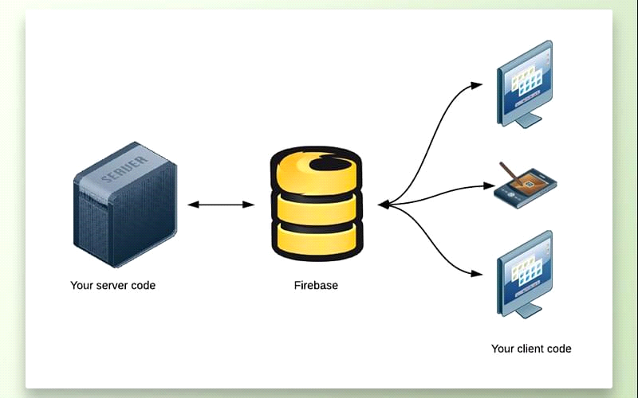

**Brief About Different Type Of Applications**

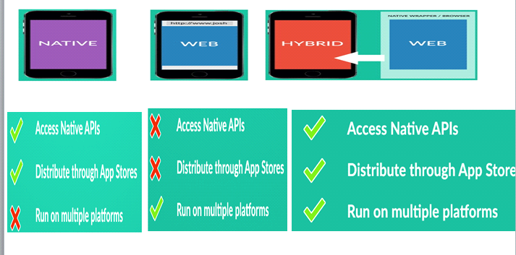

**Native application**

* Native application UI is easy to learn and understand for developer
* Allow all opretiones with no internet connection
* Distributed via app stores
* Better user experience

**Web application**

* Allow a single version to be developed and run on multiple platforms(android, appleios,windows)
* Requires no downloads from app stores
* Creation and maintenance is very easy

**Hybrid application**

* Multiple portability that is one code multiple platforms
* lower origination costs
* Common device APIs and broad device coverage
* Faster, simpler and rapid application development

**Use case Diagram**

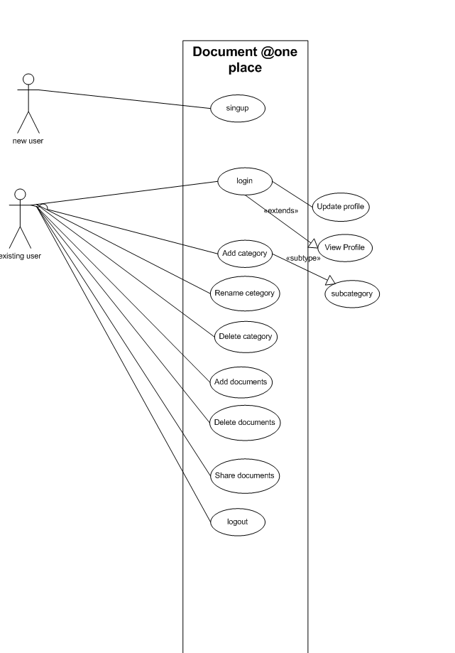

**Activity diagram**

**Login Registration Activity Diagram**

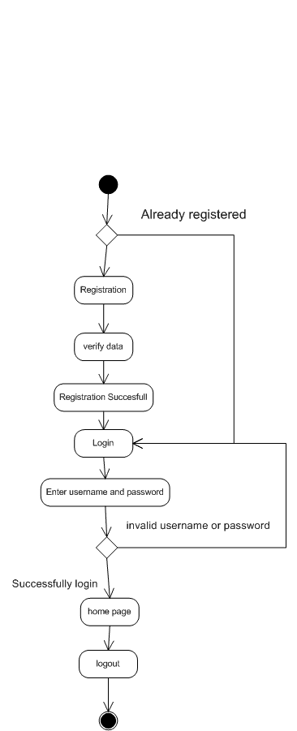

**Album activity Diagram**

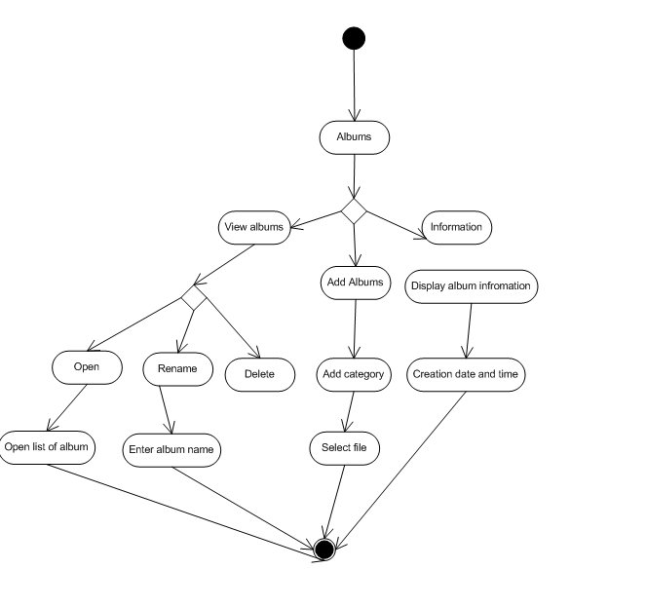

**File Activity Diagram**

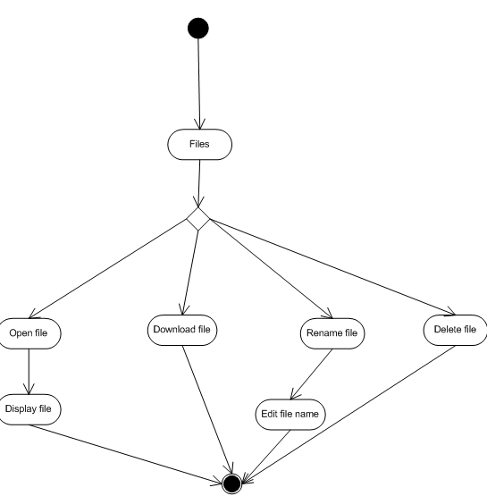

**Sequence Diagram**

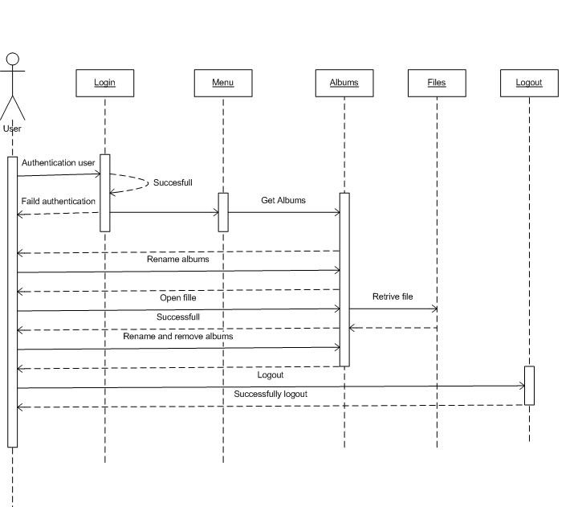

Database Json

* User
* Email id
* Password
* First Name
* Last Name
* photo
* Category
* Email id
* Category name
* Img id (1)
* Img id(2)
* Categoty name
* Image
* Img id
* image name
* image path
* image des

Screen shot

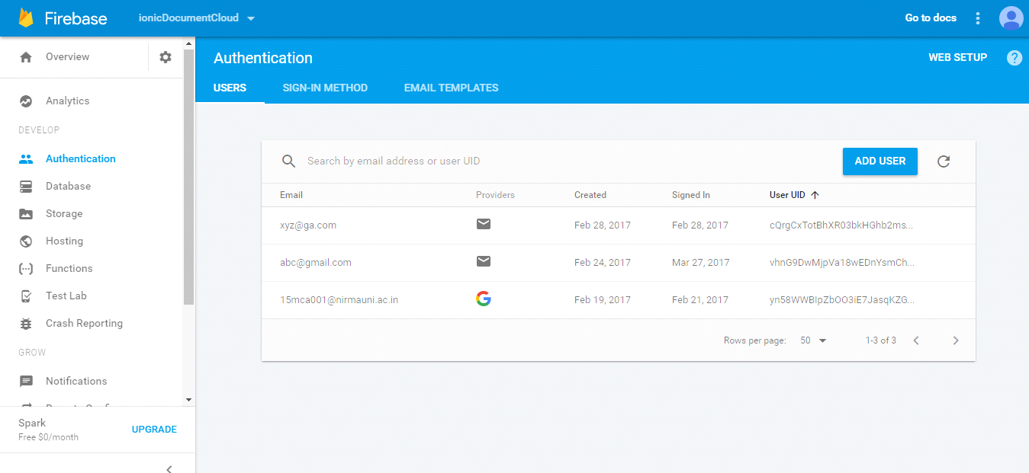

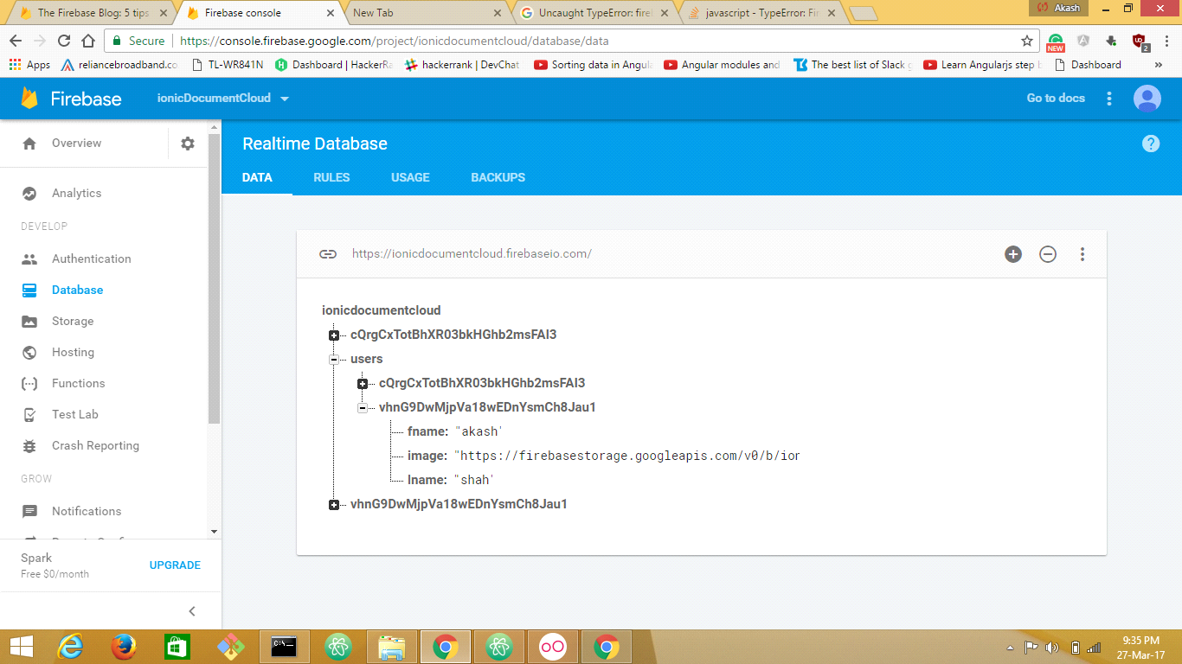

In user table user can store details like firstname,lastname,profile photo

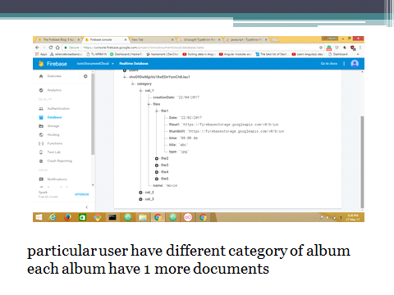

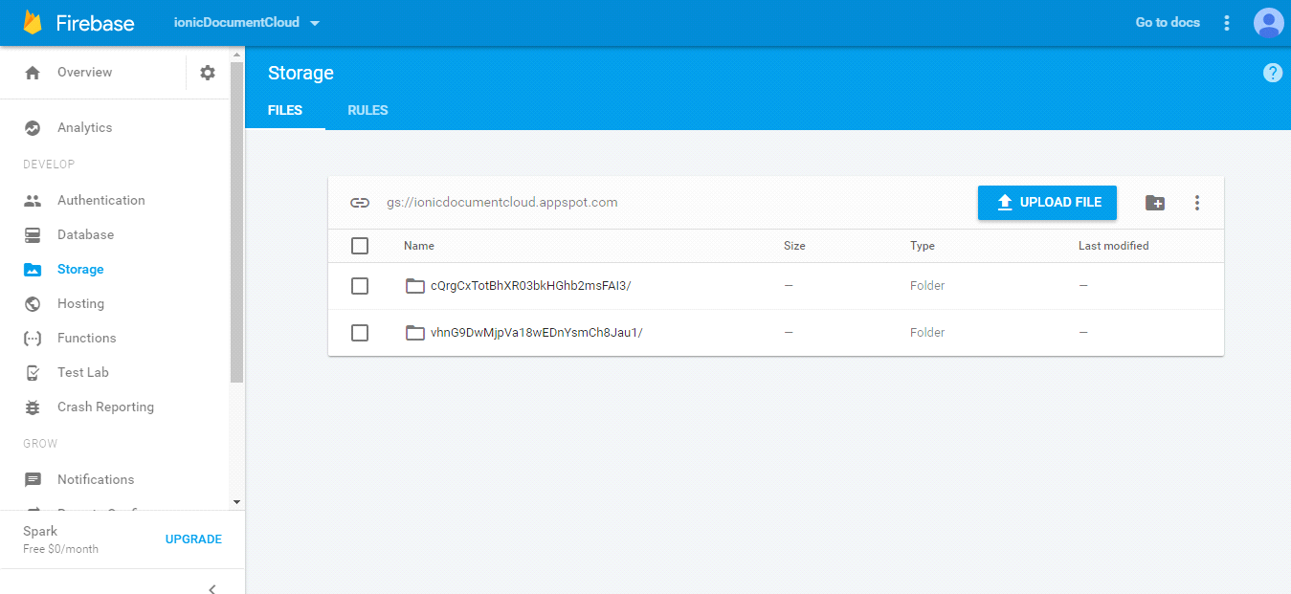

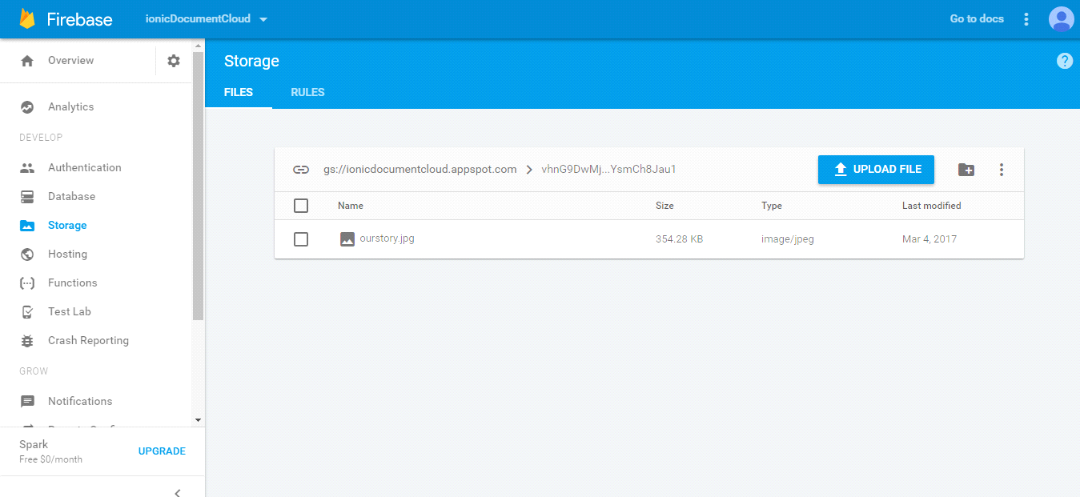

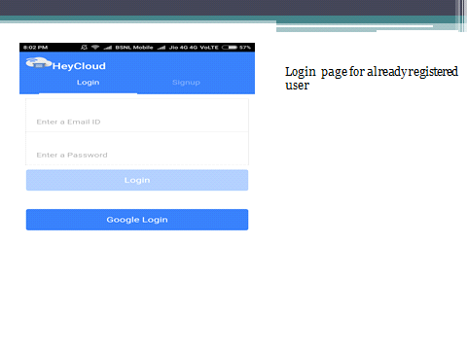

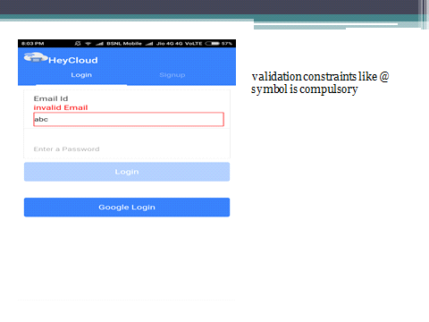

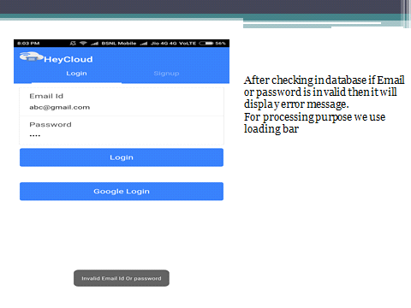

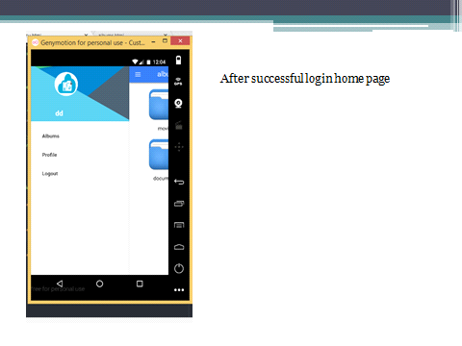

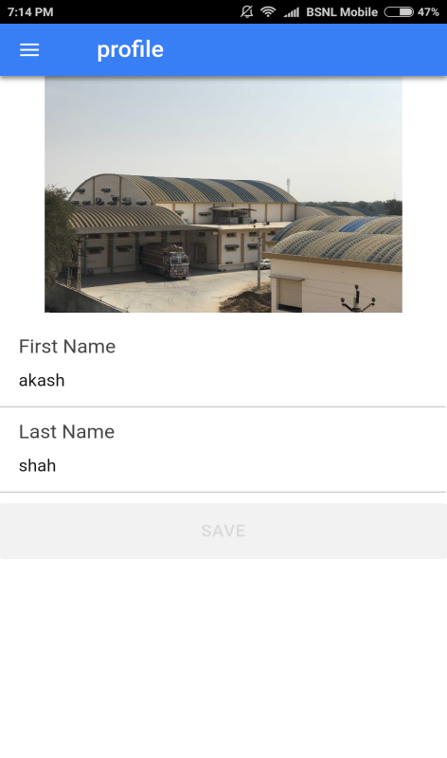

Show current user profile

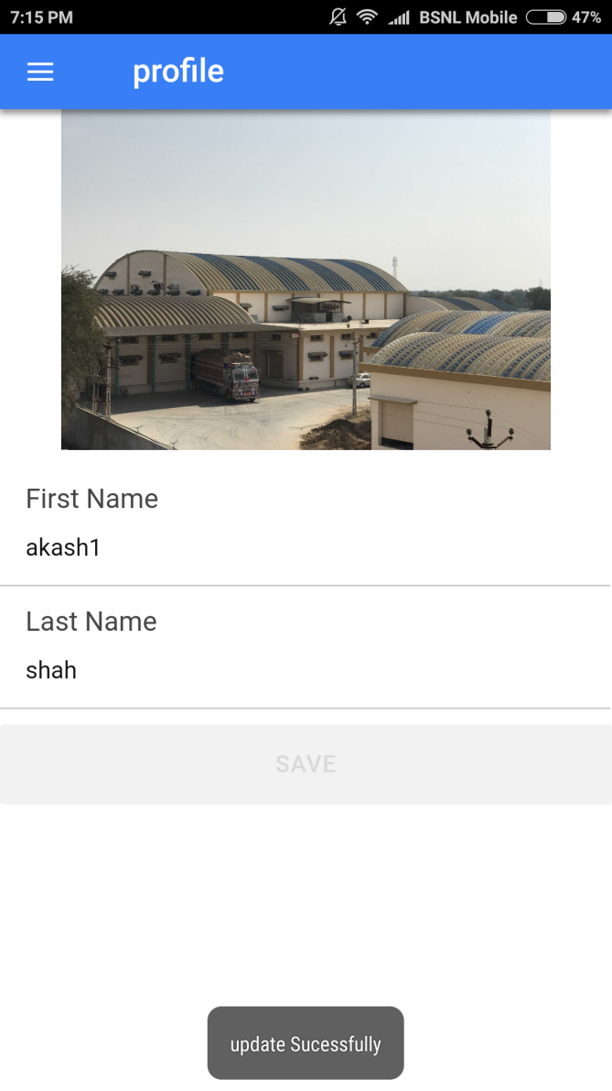

Edit profile we can change profile information.

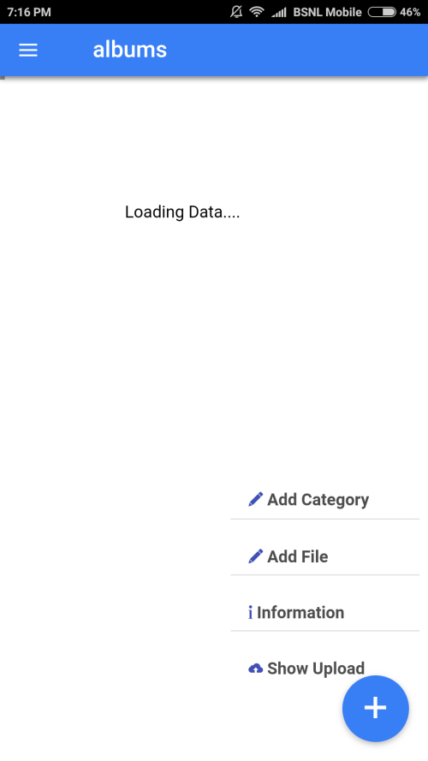

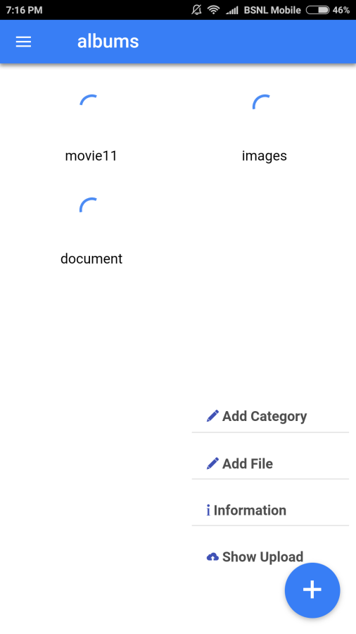

Load the folder

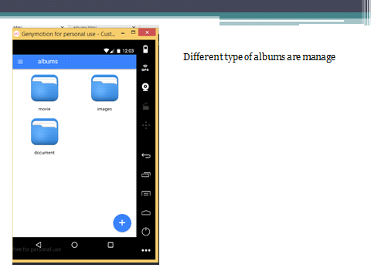

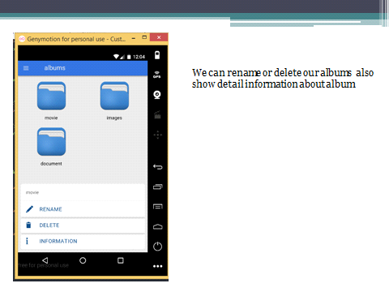

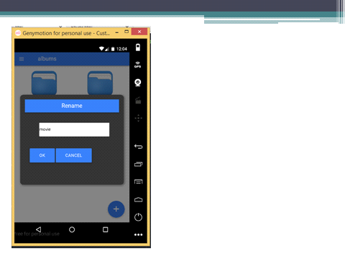

Rename folder name

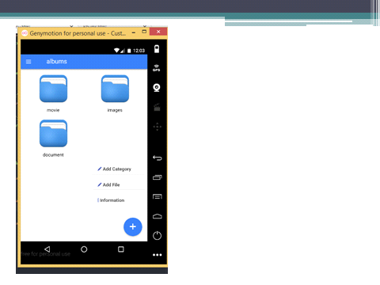

We can add category ,file and also show information .

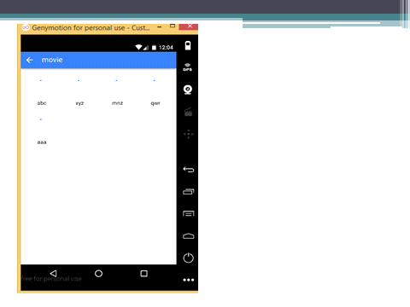

Loading documents

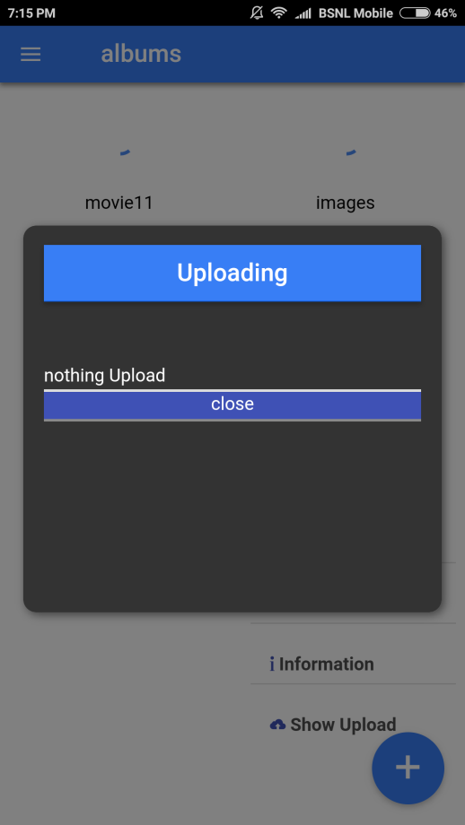

Uploading panel show upload item progress.

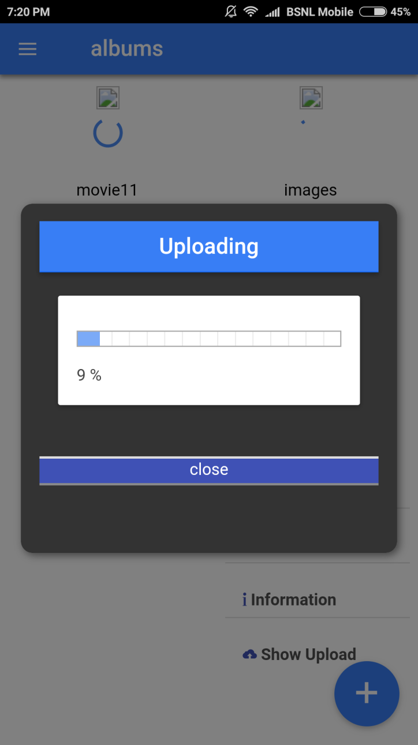

Upload document in folder.

**Future Scoop**

* Search document by location
* Folder maintain date vise
* Make slide show
* Make collage

**References**

* [www.codeproject.com](http://www.codeproject.com)
* [www.javatpoint.com](http://www.javatpoint.com)
* [www.w3schools.com](http://www.w3schools.com)
* [www.tutorialspoints.com](http://www.tutorialspoints.com)